Technology Resources to Support CCSSM
OML, 2013
Jackie Cooke & Jane Osborne
http://www.octm.org/links/math-links/jackie-cooke-s-homepage/
http://www.hoodriver.k12.or.us/Page/5021

CCSSM Links

Illustrative Mathematics | Kansas Council Flip Books
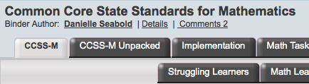  Live Binder | 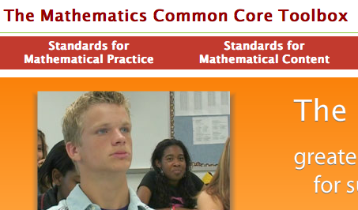  CCSS Toolbox
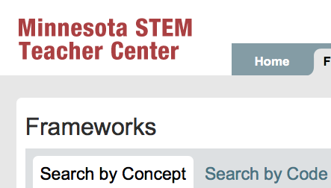  Minnesota's STEM Frameworks | ODE CCSSM Toolbox

Assessment
Math Assessment Project | New York Sample Test Items
Mathematics Design Collaborative | Smarter Balance
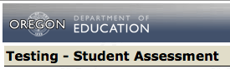  ODE Assessment Page | Mastery Connect

Math Intervention Resources

K-5 Math Teaching Resources | LearnZillion
Internet4Classroom | Study Jams
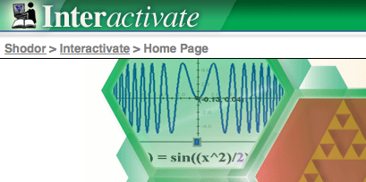  Interactivate | 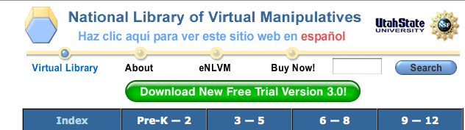  NLVM

Math Games

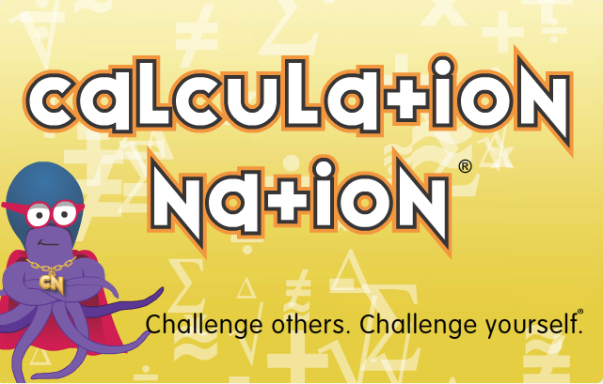  Calculationation | BBC  (Also bitesize1,2, and 3 sites)
Manga High | MathTappers
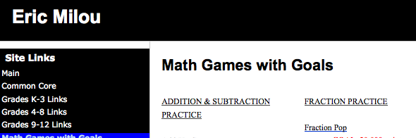  Games with Goals | 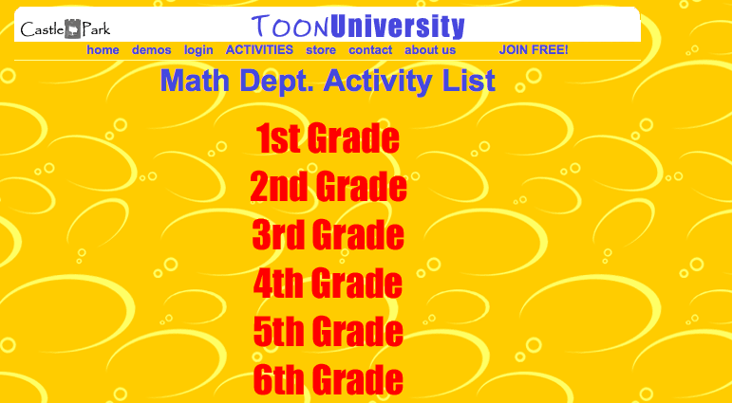  Toon University

Favorite Search Engines

NCTM Illuminations | 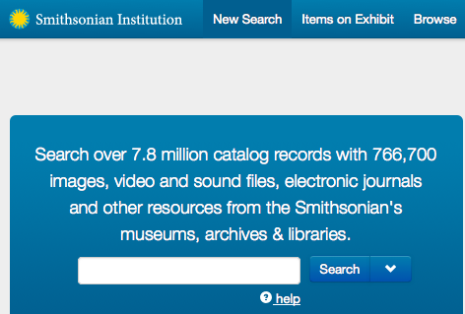  Smithsonian Collections  and also  Smithsonian Education
Wolfram Alpha | Math Snacks for Mid-School Learners
Pearson Foundation Projector Project | Learn Alberta

Favorite Teacher Productivity Tools

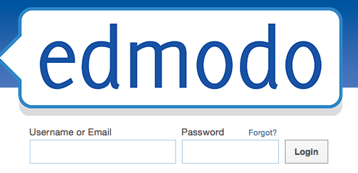  Edmodo | Do a Google search for Glogster edu and follow the link from their
Pinterest | 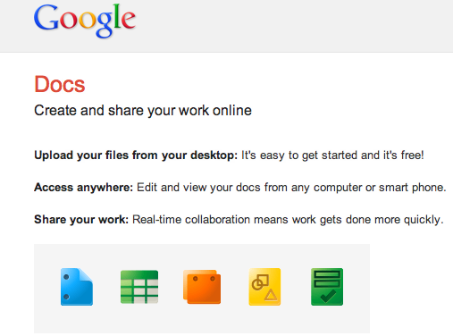  Google Docs
Prezi | 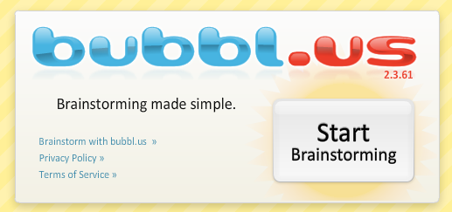  Bubbl Concept Maps

Your choice?

